JACKSONS LANDING COALITION INC.
8c / 2 Bowman Street
PYRMONT N.S.W. 2009
Incorporation Nº 180074
9 July 2020. V4

Mr Karl Fetterplace,
Senior Planning Officer
Key Sites Assessments
Department of Planning Industry and Environment
4 Parramatta Square, 12 Darcy Street,
PARRAMATTA NSW 2150.

Re: Hanson application SSD 8544
Dear Karl,
Our thanks to you and Cameron for your time in our Zoom meeting with our team on Friday 4 July.
Hanson’s latest response (the Response) provides a useful summary of the many problems with the proposed project identified in the hundreds of submissions that were made against the original EIS and against the first Response to Submissions. Unfortunately, the Response does nothing to address those problems. It remains self-evident that a large plant producing 1 million cubic metres of concrete per annum with tens of thousands of truck movements and an estimated 400 vessel movements per year would have a major adverse environmental impact. None of the technical and semantic arguments in the Response changes that.
- Summary
Noise emissions
- The project would produce unacceptable noise exceedances in Pyrmont of at least 4-5 decibels.
- Hanson has not addressed, and rejects addressing, the cumulative noise impact.
- There is confusion as to different noise conditions from the EPA, the City Council and the Port Authority – which would apply and who would do the monitoring?
- Hanson’s reasons for rejecting a curfew are absurd and untenable. They conflict with EPA policy.
- Hanson asserts the PA would regulate its activities but the PA is not a regulator and is conflicted.
- The PA’s noise policy is deeply flawed and aims to protect its tenants not the environment.
- The addition of the Hanson plant to GI would condemn local residents to live with their doors and windows closed. Even this does not prevent sleep deprivation from noise and vibration for many residents.
Concentration of vehicular traffic
- No one has properly calculated, let alone addressed, the cumulative traffic impact on GI. That includes a failure to recognise the implications of the inevitable gridlock.
- We have still not seen a proper analysis of congestion on the water.
Air quality
- There appears to be a conflict between Hanson’s analysis and the Alex Todovosky report.
- Hanson has not provided any kind of cumulative analysis and has not considered the impact of traffic congestion.
Visual impact
- Hanson concedes the high adverse visual impact that its plant would have. It would seriously disfigure views of the ANZAC Bridge. Hanson cannot mitigate this.
Impact of master plan and lease duration
- Master Planning for the Bays Precinct is not due for completion until late 2020.
- Hanson wants no restrictions on the term of its plant. This would limit the
development of Glebe Island and undermine the commercial value of the Bays Precinct Metro station.

New industrialisation of Glebe Island

- GI is a port for berthing vessels and loading, unloading, and storing materials. Hanson’s plant would constitute a new, unjustified industrial use for GI.

- Noise Emissions

Excessive noise

Page 6 of the Response says –

“the EPA has proposed project-specific noise trigger levels for Hanson’s total noise emissions (i.e. from land-side concrete batching and aggregate handling activities together with ship noise) that are consistent with the levels calculated under the Noise Policy for Industry, except for residents in Pyrmont where the trigger levels are up to 4-5 dBA higher commensurate with noise modelling for a good noise performing ship.”

Why are exceptions to the EPA’s Noise Policy for Industry (NPI) resulting in exceedances of 4-5 dBA acceptable for Pyrmont receivers, and in what way are such exceedances “commensurate with noise modelling for a good noise performing ship”? Exceedances of 4-5 dBA are significant and are no doubt an underestimate by Hanson in any event. Excessive noise at Pyrmont is precisely why the City Council wants the concrete plant moved to elsewhere on GI.

It is also worth noting that previously we were under the impression that a range of vessels would be delivering materials to the Hanson plant and that only the noisiest of these vessels might generate noise exceedances for Pyrmont receivers. It is distressing to discover that Hanson will utilise only one vessel and that vessel will generate significant exceedances. Accordingly, instead of expecting some exceedances, we now discover that every single one of its 120 vessel visits will generate exceedances.

Cumulative impact

The DPI&E (and others) specifically asked about the cumulative impact of other activities on GI. According to the Response, it’s not Hanson’s problem. Page 4 says construction support sites on GI are “subject to different standards and assessment methodologies compared to the Hanson proposal, so it is not appropriate to consider the cumulative impacts”.

Part of the problem is the scale of the new activities proposed for GI. If the Hanson concrete batching plant were allowed to proceed, it would join the Multi-User Facility (MUF), the Western Harbour Tunnel support site, the Rozelle Interchange support site, and any additional activities to be located on the island. Adding to the noise from all those activities would be trucks servicing Berths 7 & 8 and the north eastern tip of the island, as well as all the buses, cars and delivery vehicles associated with cruise ships at the White Bay cruise terminal that use Sommerville Rd for access. No one has properly assessed the cumulative impact of all these activities. It is inevitable that there will be traffic gridlock on Sommerville Rd and James Craig Rd. We suggest that no one’s modelling of the air and noise pollution has taken account of such gridlock – long lines of trucks just sitting there, engines running, emitting noise and fumes.

Confusion about various conditions

We are concerned and confused about the disparate conditions and controls on Hanson’s activities. The Response refers to different noise conditions set by the City Council, the EPA, and the Port Authority (PA). Re the City Council’s comments, page 7 says “Hanson is willing to accept conditions that reflect Council’s recommendations”. What are these conditions and who will monitor them? Page 6 of the Response says “the EPA has proposed project-specific noise trigger levels for Hanson’s total noise emissions”. What are the EPA’s specific conditions, and will they be made public?

Significantly, there is a clear conflict between the noise limits set by the EPA and those set by the PA. According to page 6, the EPA imposes a single limit on “land-side concrete batching and aggregate handling activities together with ship noise”. However, the PA’s noise policy which Hanson purports to follow (and which the PA says was drafted in consultation with the EPA) has two separate regimes with different limits for landside noise and vessel noise. Something doesn’t add up here.

Absence of a curfew

Vessel movements at night would be one of the worst environmental impacts of this development and they demonstrate Hanson’s complete unwillingness to compromise. We have frequently explained that such movements, particularly with tugs, are extremely noisy and wake up local residents. Yet Hanson refuses to entertain a nighttime curfew. Its reasoning is self-evidently absurd.

Hanson says that “weather and sea conditions” mean that it “has little control over when the ship will arrive in berth at Glebe Island”. Half the vessel movements would be vessels departing from GI. Obviously, the timing of that is not affected by sea and weather conditions and so they could be subject to a curfew. If a vessel finishes unloading at 10pm, it can simply wait until 7am next morning. As regards vessels coming to GI, they are coming from Bass Point which is only about 100 kms away.

Is Hanson seriously suggesting that, with the benefit of today’s technology such as weather forecasts and the knowledge of tides and currents, it has little control over the time a vessel setting off from Bass Point takes to travel just 100 kms? Hanson says itself that its loading activities at Bass Point “are subject to agreeable weather and sea conditions”. Therefore, vessels would only be coming in reasonable conditions. How can Hanson say that it would have “little control”?

Hanson’s second reason for rejecting a curfew is that it is making a significant investment that is “premised on the basis of the ship operating continuously”. This seems to be saying ‘because we are making a big investment, we should be able to disregard the environmental impact’?! It is not clear why local communities should have to suffer broken sleep because Hanson is making a significant investment. If continual operation has a major adverse environmental impact, it should not be allowed. It does not become acceptable simply because Hanson needs it to make its investment work. An investment that doesn’t work without causing unacceptable environmental problems should not proceed.

In a number of places, the Response refers to the EPA’s NPI. The efficacy of a curfew in the present case warrants consideration in light of the EPA’s analysis. The key provisions are as follows –
“A feasible mitigation measure is a noise mitigation measure that can be engineered and is practical to build and/or implement, given project constraints such as safety, maintenance, and reliability requirements. It may also include options such as amending operational practices (for example, changing a noisy operation to a less-sensitive period or location) to achieve noise reduction.
Selecting reasonable measures from those that are feasible involves judging whether the overall noise benefits outweigh the overall adverse social, economic, and environmental effects, including the cost of the mitigation measure. To make such a judgement, consider the following:
• Noise impacts:
- existing and future levels, and projected changes in noise levels
- level of amenity before the development, for example, the number of people affected or annoyed
- the amount by which the triggers are exceeded.
• Noise mitigation benefits:
  - the amount of noise reduction expected, including the cumulative effectiveness of proposed mitigation measures, for example, a noise wall/mound should be able to reduce noise levels by at least 5 decibels
  - the number of people protected.
• Cost effectiveness of noise mitigation:
  - the total cost of mitigation measures
  - noise mitigation costs compared with total project costs, taking into account capital and maintenance costs
  - ongoing operational and maintenance cost borne by the community, for example, running air conditioners or mechanical ventilation.
• Community views:
- engage with affected land users when deciding about aesthetic and other impacts of noise mitigation measures
- determine the views of all affected land users, not just those making representations, through early community consultation
- consider noise mitigation measures that have majority support from the affected community.”
- “Changing a noisy operation to a less-sensitive period” is specifically identified by the EPA as a “feasible” mitigation measure. The reasonableness factors then show the compelling nature of a curfew in the present case.
- “Noise impacts” – a large number of people would be “affected or annoyed”.
- “Noise mitigation benefits” – there would be a major noise reduction and a large number of people would be “protected”.
- “Cost effectiveness of noise mitigation“ – operators would be able to plan their arrivals and departures to minimise the impact of a curfew, and it would prevent an enormous “cost borne by the community, for example, running air conditioners” (the air conditioning going in a thousand apartments if the occupants had to live with all their doors and windows closed as proposed by the Port Authority).
- “Community views” – a curfew would unquestionably “have majority support from the affected community”.
The application of the EPA’s ‘feasibility and reasonableness’ test demonstrates the compelling case for a curfew on vessel movements as a minimum.

According to Hanson, the unloading time for its vessel at GI is 12 hours. That means that the vessel should be able to arrive between 7am and 10am and be gone by 10pm. There should be no need for the vessel to stay overnight at all. Why is that not a reasonable expectation of Hanson? How can a major adverse impact on local communities be considered a preferable alternative?

The single most objectionable statement in the Response appears on page 9 –

“It is certainly not suggested that residents of Pyrmont should be required to close their windows and doors 24/7.”

And yet that is exactly what the Hanson project would mean. That would be the inevitable result of adding Hanson’s 120 vessels a year to the 80 vessels from the MUF. There would be 400 vessel movements a year with tugs. Both facilities refuse to entertain a curfew so there would be vessels at berth and vessels coming and going at all times of the day and night. Pyrmont residents would have no choice but to close their windows and doors all the time, particularly at night as a vessel could turn up at any time and wake them.

In this regard, it is useful to remember just how close the proposed concrete plant would be to thousands of local residents. The photo below is taken from the proposed site on GI. The edge of the wharf can be seen in the foreground. It is in this narrow stretch of water that bulk material handling vessels would be manoeuvred by tugs. Midchannel, the moving vessels would be less than 100 metres from the closest residential apartment – 400 times a year.

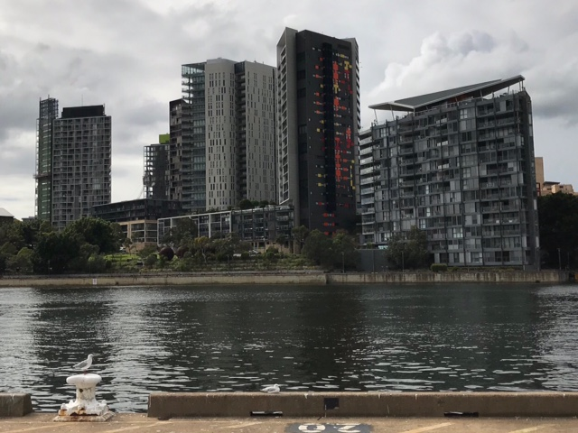

The apartments at Jacksons Landing were designed to be insulated from loud noise. There was a recognition in the design that the apartments were located near a port. The high-quality doors and windows mean that from time to time when there is noisy activity, residents can get relief by shutting their doors and windows. However, the extensive balconies and opening windows fronting the water make it clear that it was never intended that residents should be required to live in a permanent state of lockdown. Hanson has completely failed to address this fundamental issue.

On page 9 Hanson attempts to defend the sleep disturbing noise that its 240 vessel movements would create on the basis that “tugs are required for safe port operations”. This is a disingenuous observation. At no stage has anyone suggested that tugs not be used where necessary. Our point is that that tugs are extremely noisy and for that reason they should not operate at 2 am in the morning in the middle of Johnstons Bay literally 100 meters away from the high-rise apartment buildings in Pyrmont. We know from lived experience that two tugs manoeuvering a large vessel into berth wake many people up even with their doors and windows closed.

The PA’s flawed noise policy

Page 6 of the Response states that Hanson’s “vessel is consistent with the Port Authority’s proposed draft Vessel Noise Operating Protocol and the protocol's more stringent medium to longer term noise goals.” There is nothing in the way of restriction on noisy vessels in the VNOP unless the vessels have caused exceedances of more than 5 dBA on multiple occasions. It defines ‘daytime’ as lasting until 10pm. It is also false and misleading of Hanson to assert that there are “stringent medium to longer term noise goals” in the VNOP.

Hanson has relied throughout its application process on the argument that its compliance with environmental standards would be rigorously policed by the PA. This has always been a specious argument. The PA is hopelessly conflicted as the owner of GI. It has an incentive to maximise revenues from its property. It is not a regulator. It would be Hanson’s landlord and it would not want to do anything that might hamper Hanson or dissuade other potential tenants for GI.

We are undertaking a detailed analysis of the PA’s noise policy. That analysis is far from complete. However, given the supposed importance of the PA and its policy on Hanon’s behaviour and activities, it is worth briefly summarizing some of the key weaknesses of that policy.

- It adopts a dual noise source approach, setting different noise limits and rules for ‘landside’ activities and for ‘vessels’. The effect of this approach is to allow higher total noise levels.
- Its application is restricted to the MUF and the proposed Hanson plant i.e. it ignores other GI activities and does not assess cumulative noise impacts.
- It excludes vessel movements altogether from noise control on the specious grounds that (1) the noise that vessels generate on arriving and departing is not ‘representative’ of vessel noise and (2) tugs are necessary for safety. (It will be cold comfort to local residents that the noise that wakes them at 2am is not ‘representative’ and no one is suggesting tugs should not be used.)
- It sets high ‘nominal’ noise limits relative to a range of relevant factors such as WHO recommendations and overseas standards.
- In any event, even those nominal limits will not be applied in many circumstances. For example, there are effectively no daytime noise limits if an operator says that excessive noise is a result of unloading quickly so as to minimise noise at night!
- It proposes no obvious mitigation measures such as vessel silencers and the orientation of berthed vessels.
- It rejects, without justification, any kind of curfew. Bizarrely, it analyses aircraft noise in some detail but conveniently makes no mention of airport curfews.
- It voluntarily places significant restrictions on the PA’s ability to improve noise pollution in the future. For example, it says that vessel noise limits can only be lowered at the time of a three review and then only by a maximum of 2 decibels. Furthermore, the limits can never be lowered below 50 decibels.
- As noted above, the compliance regime in the VNOP is so weak as to have almost no effect in practice.
- It is essentially a commercial document to provide certainty and protection to PA tenants rather than to protect the environment.

- Concentration of vehicular traffic

If the Hanson plant were to proceed, traffic on Glebe Island would include trucks from that plant as well as from the MUF, the Western Harbour Tunnel support site, the Rozelle Interchange support site, activities at GI 7&8, activities at the north eastern tip of the island, and any additional activities that are located on the island, as well as buses, cars and delivery vehicles associated with cruise ships at the White Bay cruise terminal that use Sommerville Rd and trucks and delivery vehicles associated with the construction of the Bays Precinct station as part of Metro West.
We have seen so many different numbers in the REF, the PA’s RtS, the EIS, Hanson’s first RtS and the latest Response, plus various emails about the Rozelle and Western Harbour Tunnel support sites.
It was only three months ago that the state government released its update for Metro West including details about the construction of the new Bays Precinct station. That will start next year and last for at least three years. The latest documents reveal that during the tunneling process there will be “990 trucks per day and 251 light vehicles per day”.
https://www.sydneymetro.info/sites/default/files/document-library/Westmead_to_the_Bays_and_Sydney_CBD_Environmental_Impact_Statement_summary_final_1.pdf
Site access will be via Port Access Rd and James Craig Rd. These are the same roads that would be used by vehicles from all the other activities on GI. Is anyone really on top of the traffic numbers for all these various projects and activities? Has anyone fully considered the implications for congestion? We are concerned that the PA only wants to maximise its revenue from GI and no one else has properly analysed the cumulative traffic impact.
Hanson refers at one point to 172 trucks per hour. That is a truck every 21 seconds just from Hanson. Collectively the other projects involve hundreds and hundreds of vehicles an hour. As noted above, the combination of the traffic from all these projects would inevitably cause gridlock on occasions – long lines of trucks backed up with engines running. Did the experts who modeled air pollution take account of this gridlock? Did they factor in the fumes pouring out of trucks sitting on GI waiting for traffic jams to clear or did their models assume that trucks would drive straight in and out?
What about the noise modelling? Did it allow for traffic jams? We think we know the answers to these questions which is why we believe the air and noise pollution predictions have understated the environmental impact.
Given the various predictions we have seen about traffic levels, including those for the recently added Western Harbour Tunnel and Rozelle Interchange support sites and the Bays Precinct metro station, we submit that it is now obvious that the Hanson plant would be a ‘bridge too far’. Hanson has still not presented appropriate qualified and independent analysis of the cumulative impact of its proposal to justify its claim that that proposal would not have any significant environmental impact.
Road traffic is not the only issue. We question whether anyone has undertaken a proper assessment of the potential for congestion on the water. We have raised this issue before but it has never been answered. The photo below was taken last Friday. It shows one of the Polaris Marine barges that go through Johnstons Bay to Blackwattle Bay all the time. There is a constant stream of boats, large and small, through this narrow channel. Has the impact of Hanson vessels (arriving, departing, and at berth at GI 1) on traffic in this stretch of water been adequately reviewed?

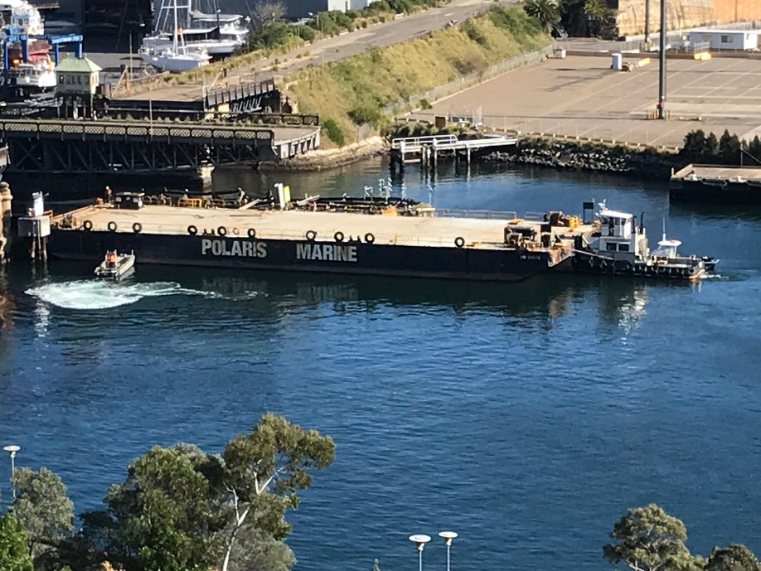

- Air Quality

There is a lack of independent data except for the Alex Todovosky report supplied by the DPI&E. That report seems to conflict with the views of Hanson’s air quality consultants.

Hanson has not provided a proper cumulative analysis of the air quality issue. Furthermore, as discussed above, the scale of the water and land traffic has not been properly determined so that the implications of events like traffic gridlock have not been adequately modelled.

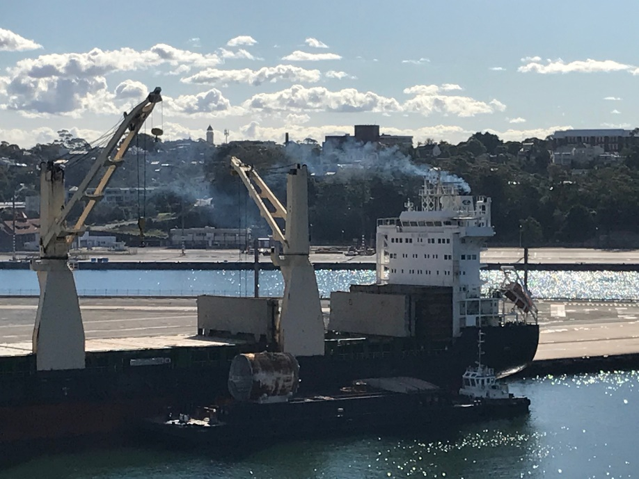

This photograph highlights a frustrating aspect of the entire Hanson application process for local communities. It is a picture of the reality so often denied in Hanson’s documents. Hanson has presented a raft of ‘evidence’ provided by its captive ‘experts’. Those experts present complex and highly technical evidence as to why Hanon’s plant would have minimal impact on the local environment. Yet the lived experience of the people who actually live in the affected areas is frequently inconsistent with that evidence. For example, we are told that there will be no adverse impact on air quality. However, we know that when vessels are berthed at GI 1&2, we can often see, smell, and taste the fumes that they generate. That isn’t based on ‘modelling’ or ‘predictions’. It is a simple fact. Accordingly, irrespective of what Hanson’s hired guns have asserted, we know that if Hanson’s vessel is allowed to berth at GI 120 times a year, on top of 80 visits by MUF vessels, the cumulative air quality impact on the thousands of people living at Jacksons Landing will be disastrous.

- Visual Impact

The Response effectively concedes defeat on this issue. It makes no attempt to deny the significant adverse visual impact of the Hanson project. In terms of ‘mitigation’, it talks about “public art strategies” and “landscaping strategies” but at the end of the day it is proposing a concrete plant. There is no dressing that up.

It is useful to repeat Hanson’s own assessment of visual impact which is summarised in Table 6 on page 46 of the EIS -

- Observer Location Visual Impact
1: Peacock Point, Balmain East High to Moderate
2: Birrung Park, Balmain High to Moderate
3: Mansfield Street, Rozelle; High to Moderate
4: Glebe Foreshore Walk High
5: Glebe Foreshore Walk (The Boathouse on Blackwattle Bay) Moderate
6: Pirrama Park, Pyrmont High to Moderate
7: Waterfront Park, Pyrmont High
8: ANZAC Bridge. High to Moderate

From seven of the eight observer locations, Hanson admits that the visual impact of its plant would be either ‘high’ or ‘high to moderate’.

The true horror of these assessments can only be appreciated from Hanson’s own photomontages from Appendix E of the EIS –
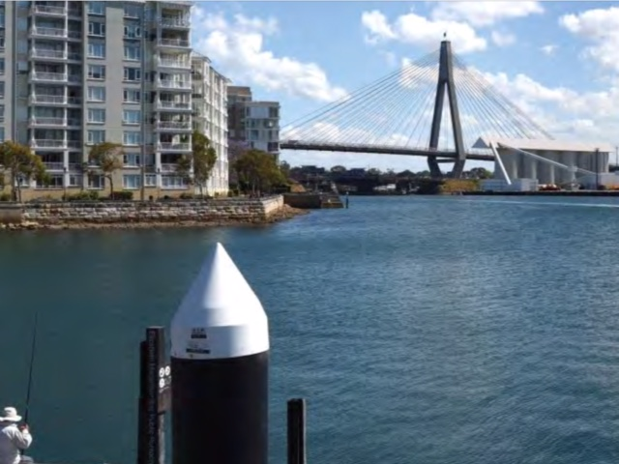

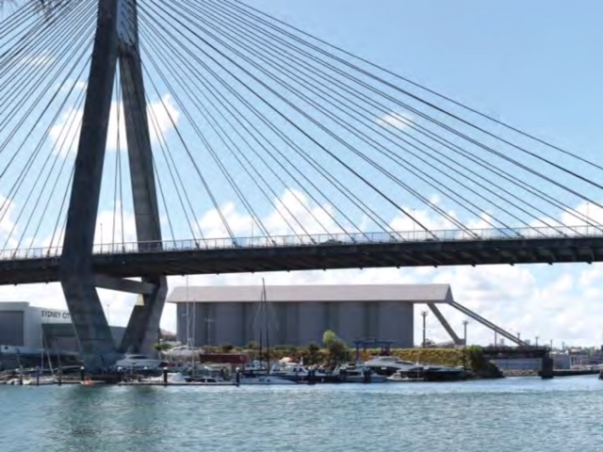

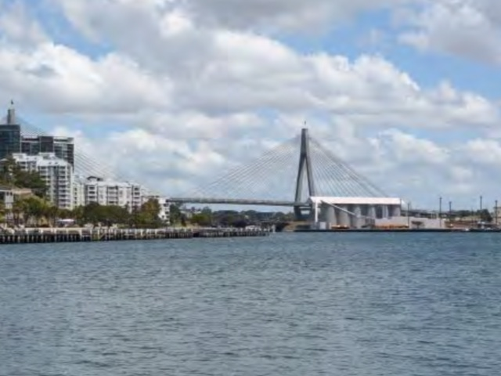

Hansons’ own pictures confirm that allowing the proposed concrete plant to proceed would be an act of visual vandalism. (And it is worth remembering that these photomontages were prepared by experts instructed to minimise the visual impact of the plant as much as possible! No doubt the reality would be even worse.)

The silos for Hanson’s plant would be 34 metres high which as the photos show is much higher than the carriageway at the western end of the ANZAC Bridge. The bridge is a beautiful piece of engineering. Its elegant lines have made it a Sydney icon. It can be seen from many places around the harbour including from the new park at Barangaroo. Do we really want tourists on cruise ships at White Bay, on ferries, or walking around the city’s parks and board walks to see this concrete carbuncle?

Hanson has not provided any photomontages of the visual impact at night. Based on the photo below of the current look of the bridge at night, it doesn’t take much imagination to realise that the nighttime impact of the Hanson plant would be even worse than the daytime impact.

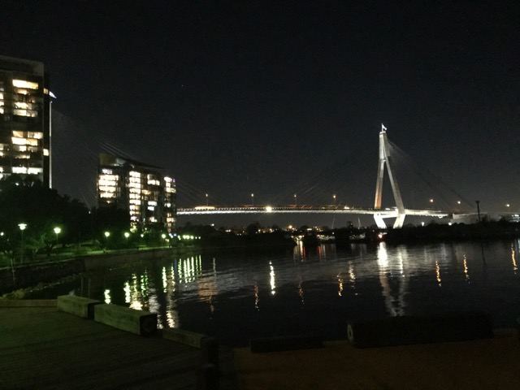

As a final point, we note that we are no fans of the PA’s MUF. However, it is barely half the height of the Hanson silos, it is much further from the ANZAC Bridge and it is a flat, symmetrical building very different to a concrete plant. Therefore, Hanson cannot run the argument that its plant would not change the visual environment. As a reminder here is a drawing from Hanson’s EIS: -

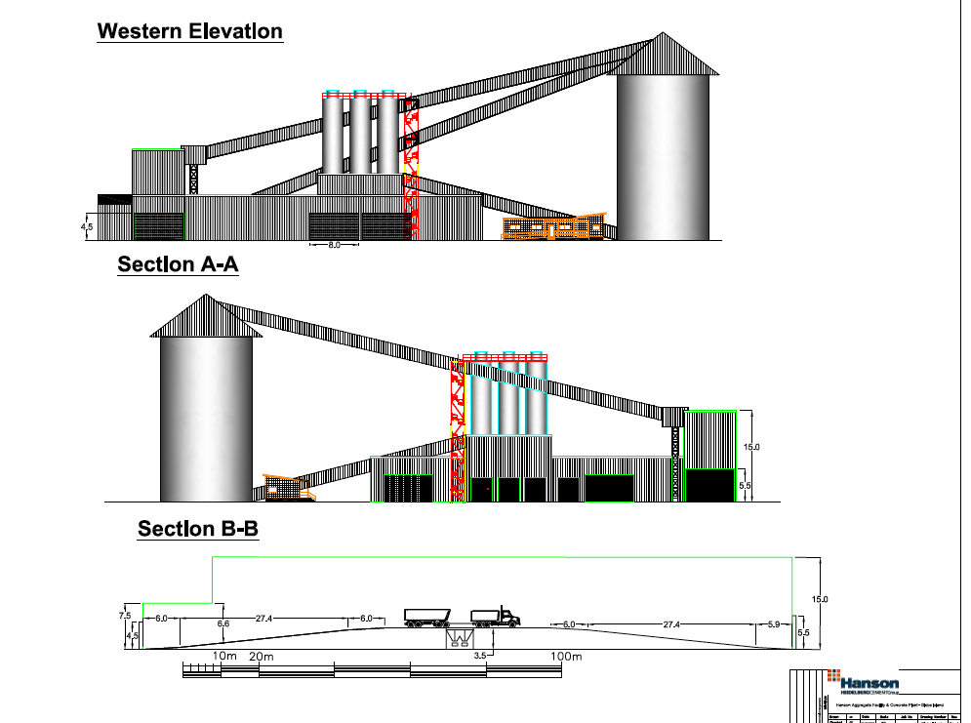

- Impact of master plan and lease duration

Master Planning for the Bays Precinct is still under way and not due for completion until the end of 2020. One of its considerations is the re-opening of the old Glebe Island bridge for pedestrians and cyclists. This will impact directly on the Hanson site.

If Hanson is permitted to build and operate, its lease should not extend beyond 2025 otherwise the rest of the Bays Transformation Plan will be curtailed or prevented and the development potential and commercial value of the Bays Precinct Metro West station will be seriously undermined.

- New industrialisation of Glebe Island

Page 15 of the Response concedes that the proposed Hanson concrete plant would not be an ‘existing use’ of GI. This is an important point. GI is a port. It is used to berth vessels, to load and unload vessels, and to store materials. On page 7 of its draft noise policy, the PA goes into great detail to distinguish between a port and an industrial site and to argue that GI is the former not the latter. Hanson is proposing something new and different for GI – an industrial plant for the manufacture of concrete. There is nothing in the Response to justify this industrialisation. It is not an extension of the type of activity carried on at Glebe Island.

There now seems to be a suggestion that the Hanson plant might be a ‘road only’ operation with aggregate brought in by truck rather than vessel. If that were the case, the plant would have no connection whatsoever with the port and there would be even less justification to build it on GI.

Hanson also says that G1 & 2 “have over the years been used for intense shipping and port related activities”. There have never been more than a few vessels a year since the car import operation ceased in 2008. Many of the high-rise apartment buildings in Jacksons Landing have been built since then. What is proposed now would include 400 vessel movements a year just for the MUF and the Hanson plant.

We believe the Hanson plant would clearly be a bridge too far in the heart of Sydney and urge the DPI&E to recommend against its approval by the IPC.

